Local Scope

📌 Definition:
# Source: AI Source: Provided by: [Data Path: Persons Table -> ID Column: 1, Name_En Column: Motasem Essam] -> From: [Chatgpt (GPT‑5 Mini)] on [12/9/2025]
Local scope refers to variables that are declared inside a method, function, or block and can be accessed only within that specific block.

🧠 Simple idea:
# Source: AI Source: Provided by: [Data Path: Persons Table -> ID Column: 1, Name_En Column: Motasem Essam] -> From: [Chatgpt (GPT‑5 Mini)] on [12/9/2025]
Local Scope = “Visible only here” 📍

🔍 Key characteristics:
# Source: AI Source: Provided by: [Data Path: Persons Table -> ID Column: 1, Name_En Column: Motasem Essam] -> From: [Chatgpt (GPT‑5 Mini)] on [12/9/2025]
- 📍 Defined inside a method or block
- 🔒 Accessible only within that block
- ❌ Cannot be accessed outside
- 🧠 Exists only during the execution of the block

📌 Example (Java):
# Source: AI Source: Provided by: [Data Path: Persons Table -> ID Column: 1, Name_En Column: Motasem Essam] -> From: [Chatgpt (GPT‑5 Mini)] on [12/9/2025]
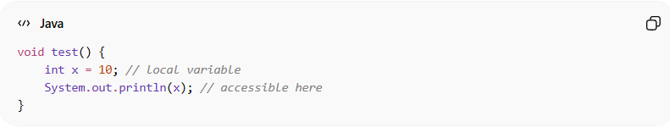
void test() {
int x = 10; // local variable
System.out.println(x); // accessible here
}

❌ Outside the method:
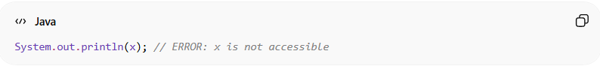
System.out.println(x); // ERROR: x is not accessible

📌 Example with block scope:
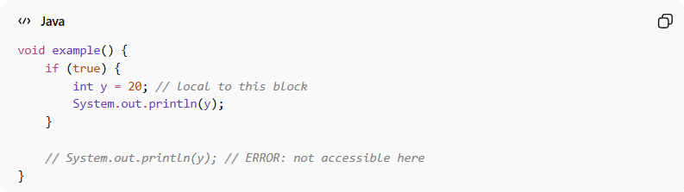
void example() {
if (true) {
int y = 20; // local to this block
System.out.println(y);
}

// System.out.println(y); // ERROR: not accessible here
}

🎯 Why local scope is important:
# Source: AI Source: Provided by: [Data Path: Persons Table -> ID Column: 1, Name_En Column: Motasem Essam] -> From: [Chatgpt (GPT‑5 Mini)] on [12/9/2025]
- 🔒 Protects variables from unintended access
- 🧩 Reduces naming conflicts
- 🧠 Keeps code clean and organized
- ⚙️ Saves memory (temporary usage)

🎯 Summary:
# Source: AI Source: Provided by: [Data Path: Persons Table -> ID Column: 1, Name_En Column: Motasem Essam] -> From: [Chatgpt (GPT‑5 Mini)] on [12/9/2025]
Local scope limits variables to the block where they are declared, ensuring they are used only where needed and not accessible elsewhere.

